SQL sEcurity policy – Adventure WORKS BELLEVILLE SITE
  - Date: 15th November 2024

- PROJECT BACKGROUND AND DESCRIPTION
After this year, Adventure Works Corporation is pleased to announce the up and running of the new facility in Belleville as from November 15. These include the core departments to be covered by this new site, which are accounting, purchasing, sales, and inventory. Because of this, creating a strong and proper SQL security policy is paramount to avoiding any unfortunate incidence leaving our SQL databases insecure. This document aims at presenting information on how security can be achieved on our SQL databases before implementing it.

- PROJECT SCOPE
The idea of this policy is to protect the Adventure Works database since it focuses on the creation of SQL users, its Authentication and permission rights at different levels. This can simply be said to be our main aim of providing security to the information that we deal with so that only the persons or rather departments that should have access to such information do so.

- PROCEDURE
Creating SQL Users
- Open your SSMS and login using windows authentication by providing your correct username and password.
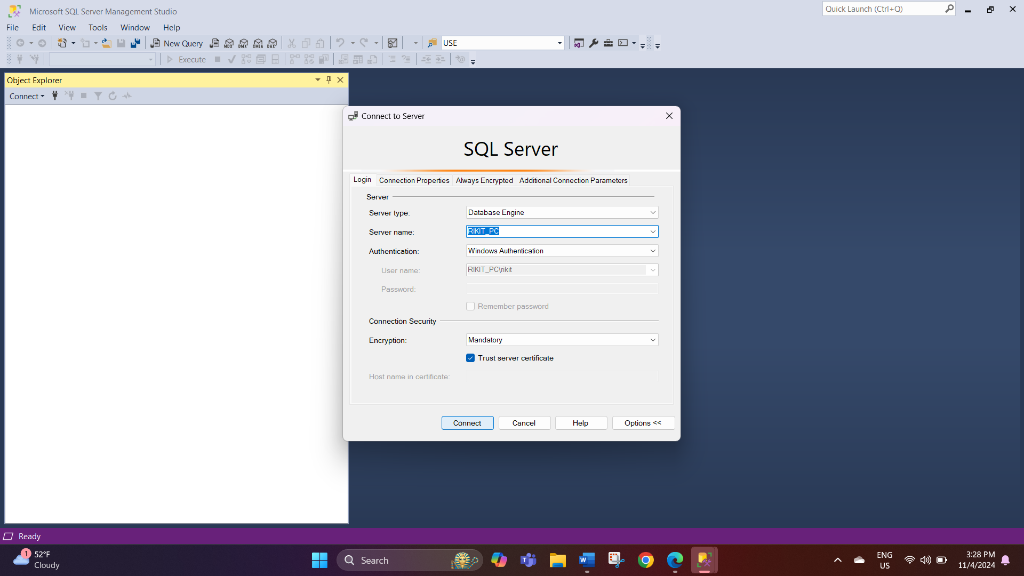
- Go to the logins and check your password of System administrator in case if you don’t know the password you can change it because you must connect your database engine as SA before creating the users.
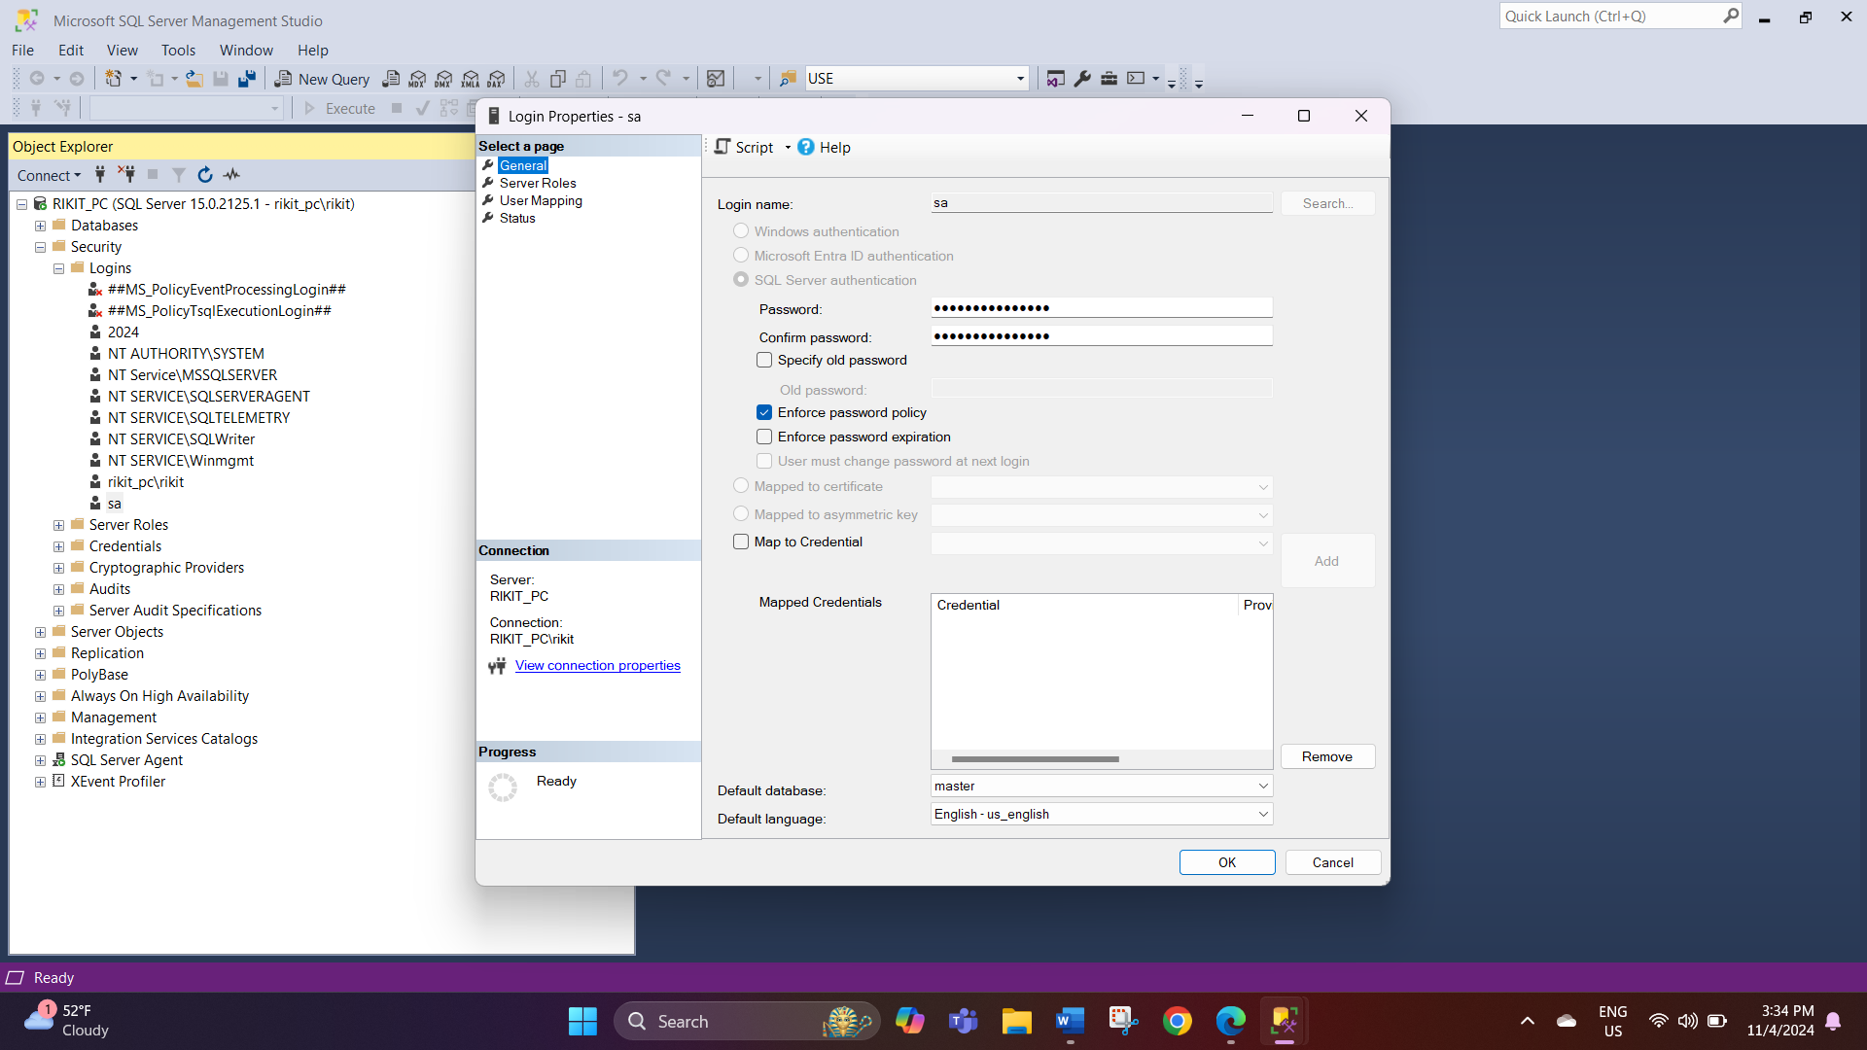
- Log to the SQL Server with the system administrator login. Choose the SQL server Authentication mode and then enter your right login details and password and click on connect.
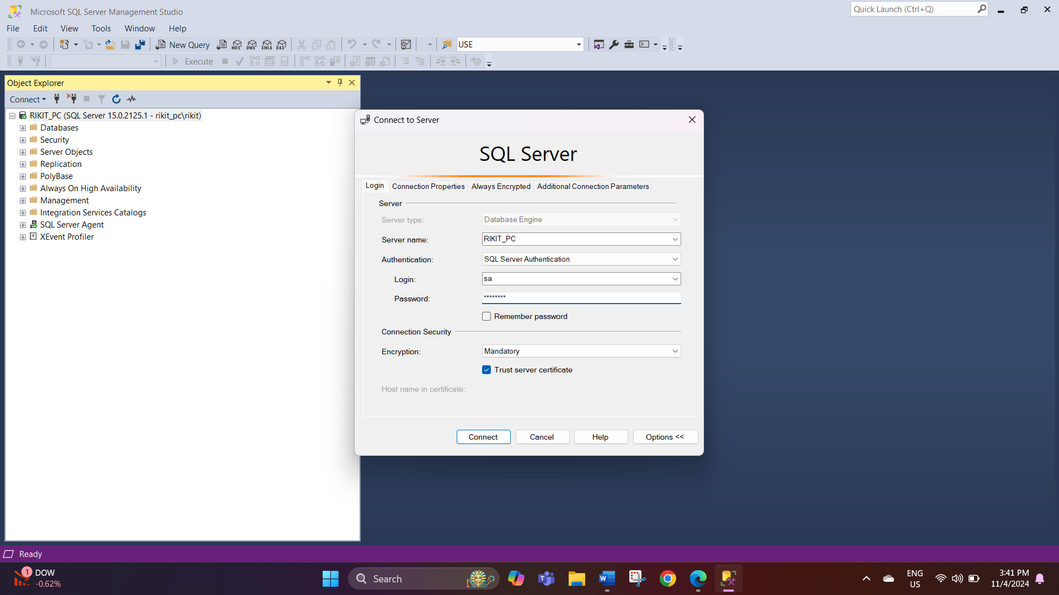
- To access this section, sign in as the administrator, click on the down arrow to expand the security folder and then logins, right-click logins and go to new login.
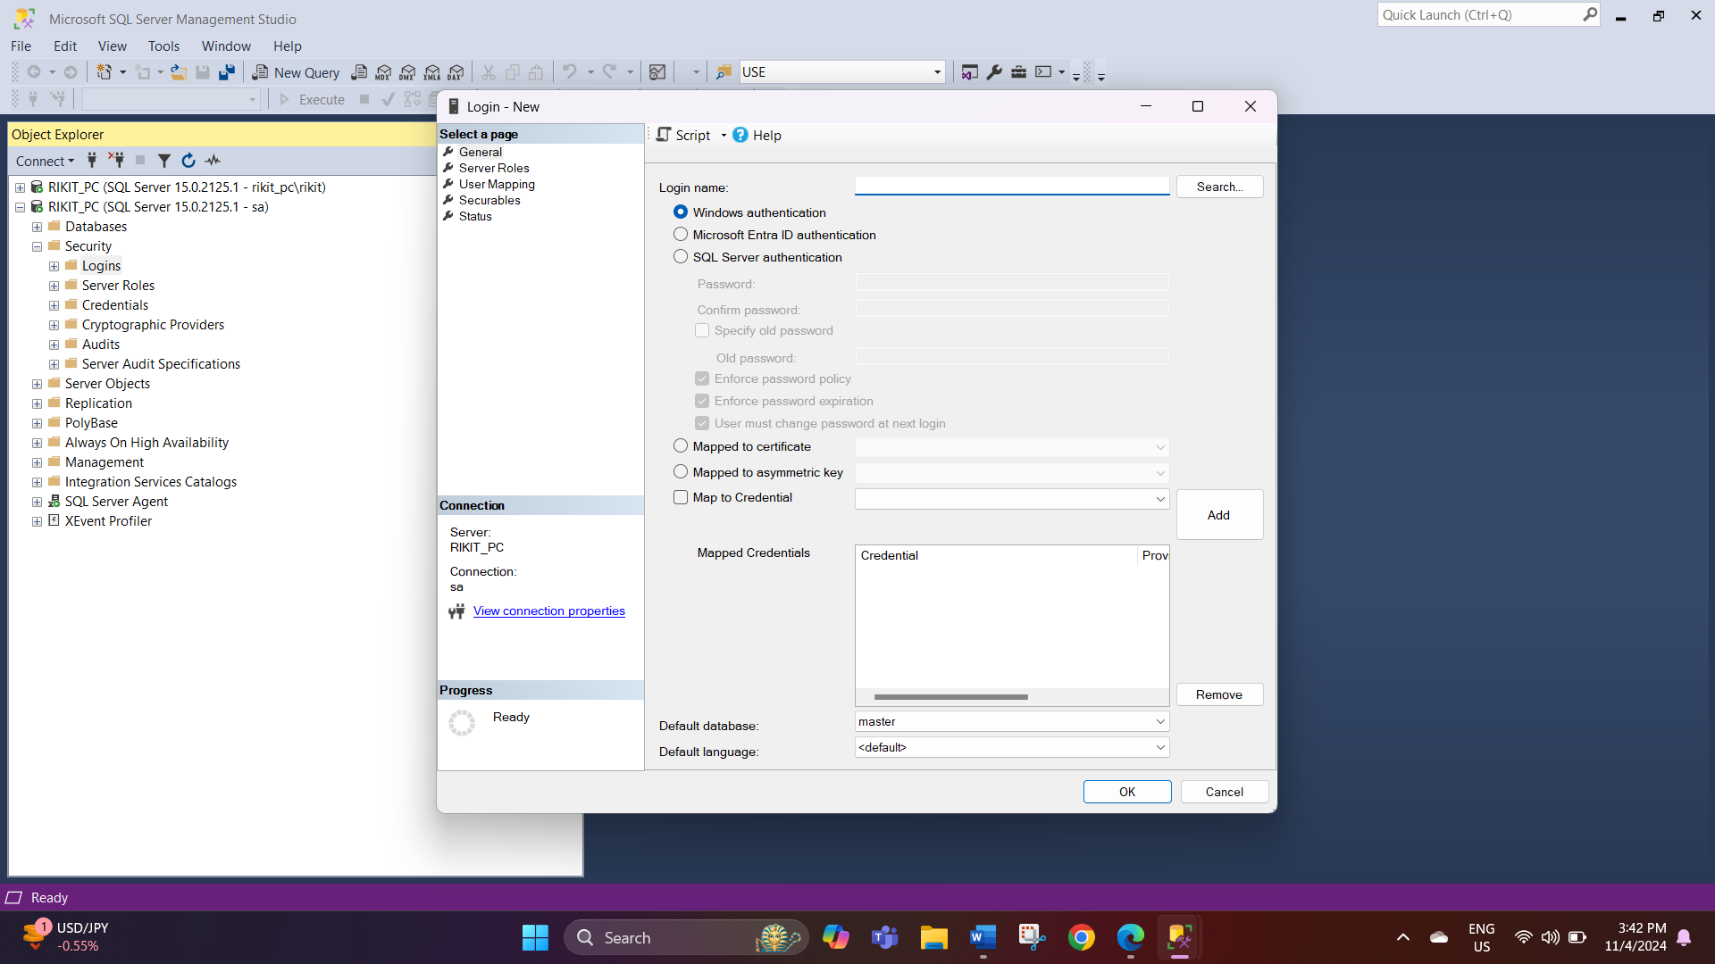

- In the login name box, key in the username of your preference, choose SQL Server Authentication then type in a password before clicking ‘Ok’. Here it is name as Rikit_User_1
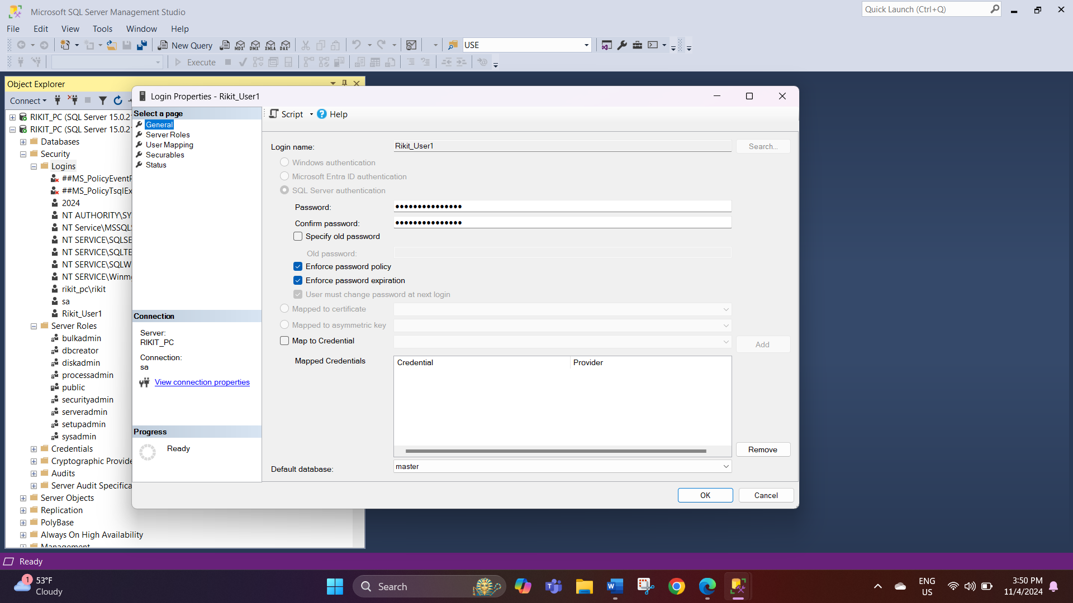

- Perform the same steps as stated above and create the second user .Here, Iam using Rikit_User2.
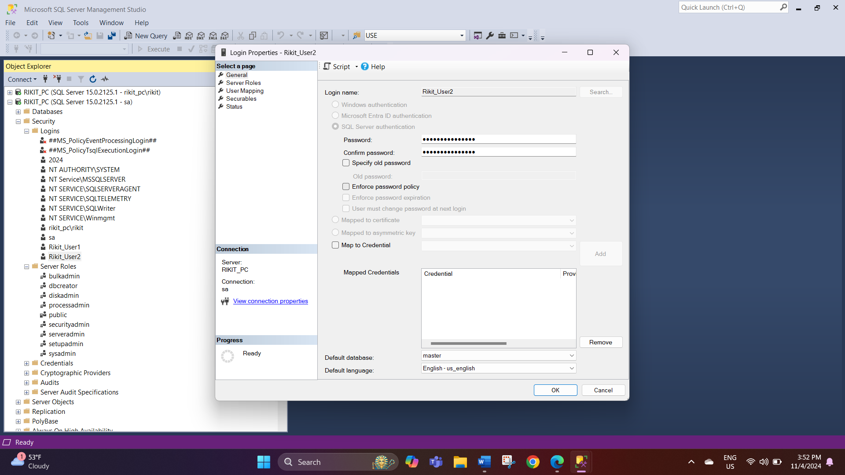

Server Level Permissions
- Go to the Properties and right click on Rikit_User1.
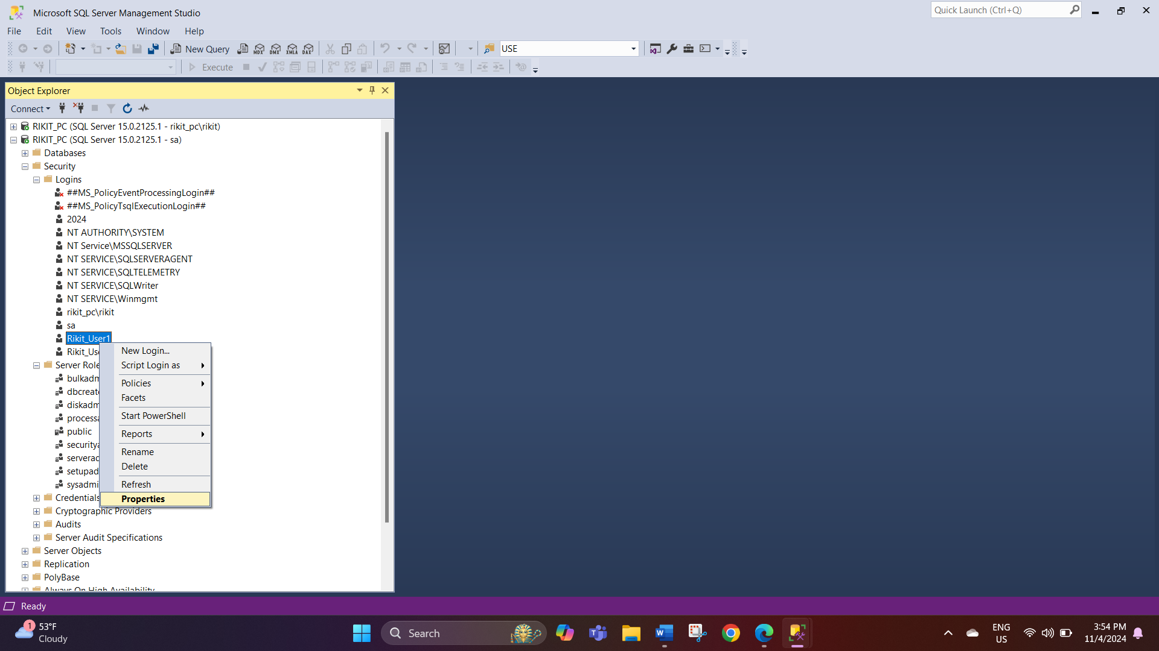
- In the Login Properties window you are at the Server Roles page make and provide the public role.
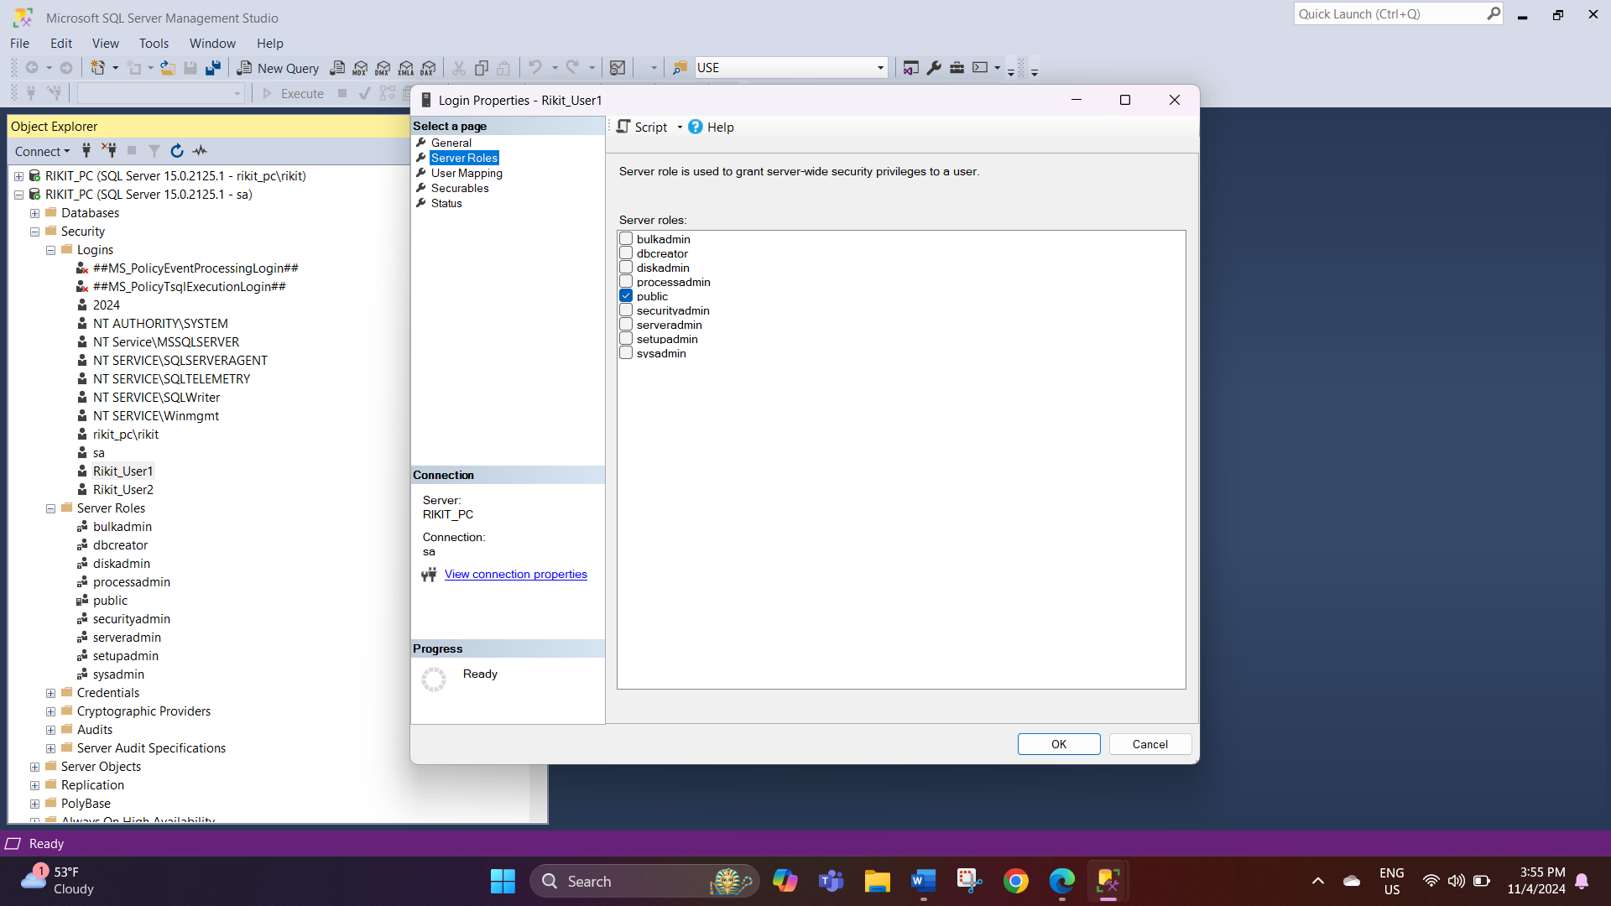

- Click the ‘User Mapping’ link on the page, on this page, choose the Adventure Works database. Then add the roles db_datareader and db_datawriter to it and click on OK.
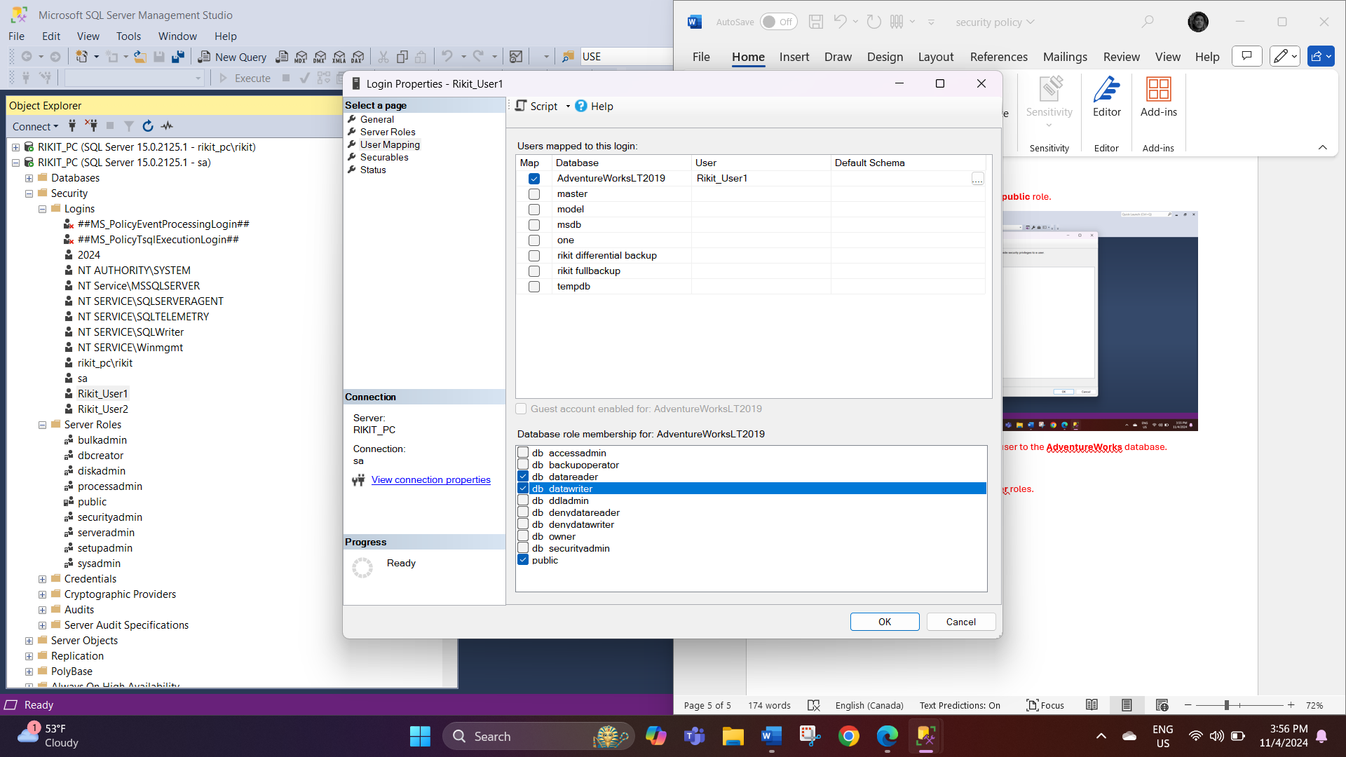

- Next there will be another secure page which requires permission to connect the sql and click on ok.
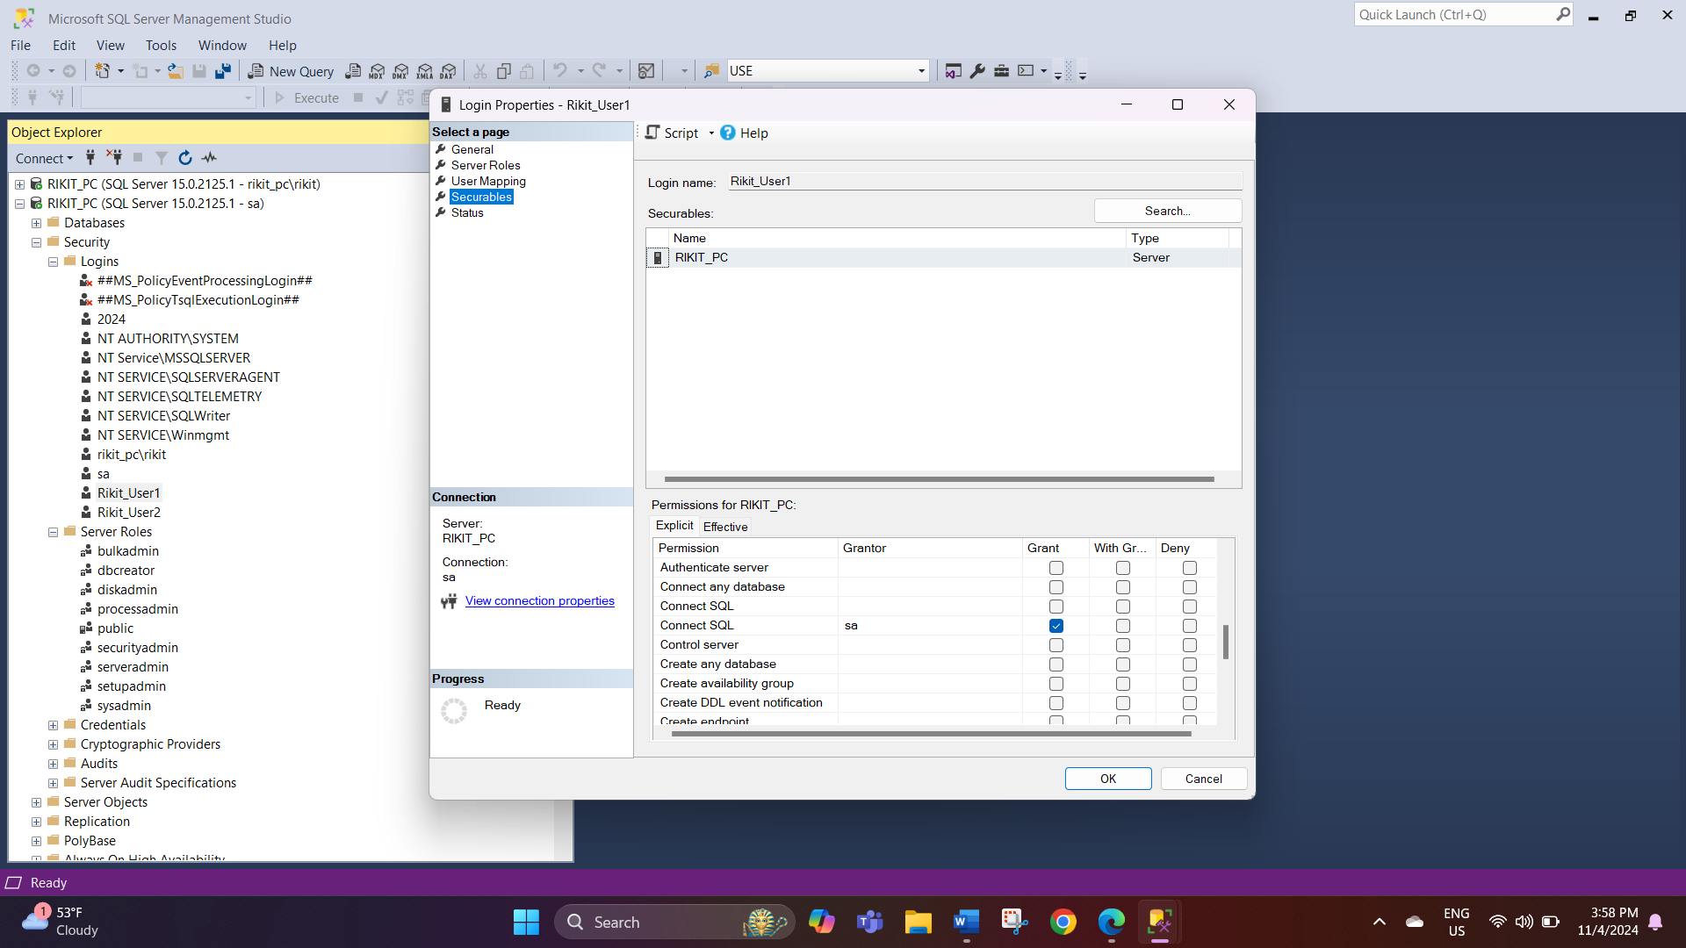

- On the status page grant permission to connect to the database engine and enable the login, then click ok.
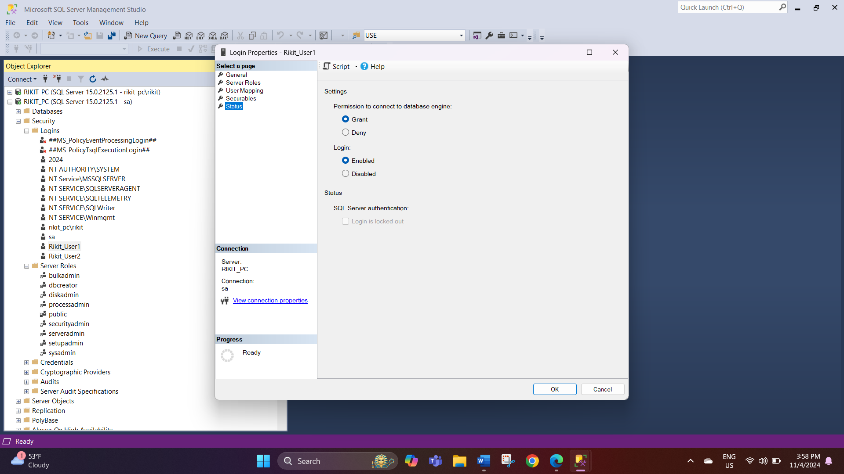
- The second user to which the roles that we have created have to be assigned should follow the same instructions as above.
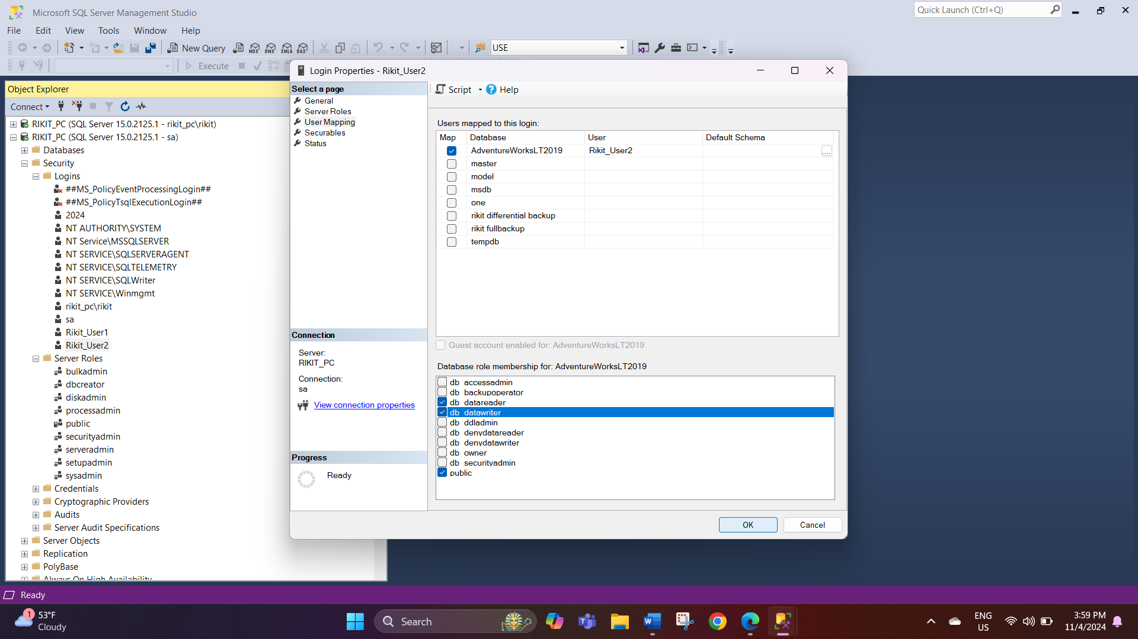

Assign Table-Level Permissions
Granting the permission for user 1
- Expand the Adventure Works database and select adventureWorks2019.click on the security options and then users.
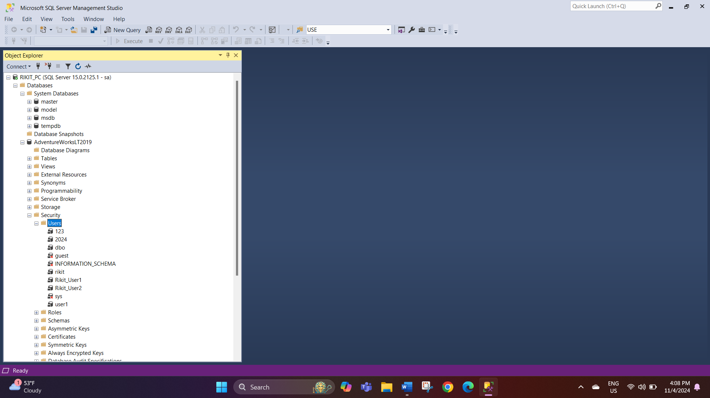

- On the users section you can view the users that include the ones that you have created. Click on Rikit_User1 and click on the properties on the right click.
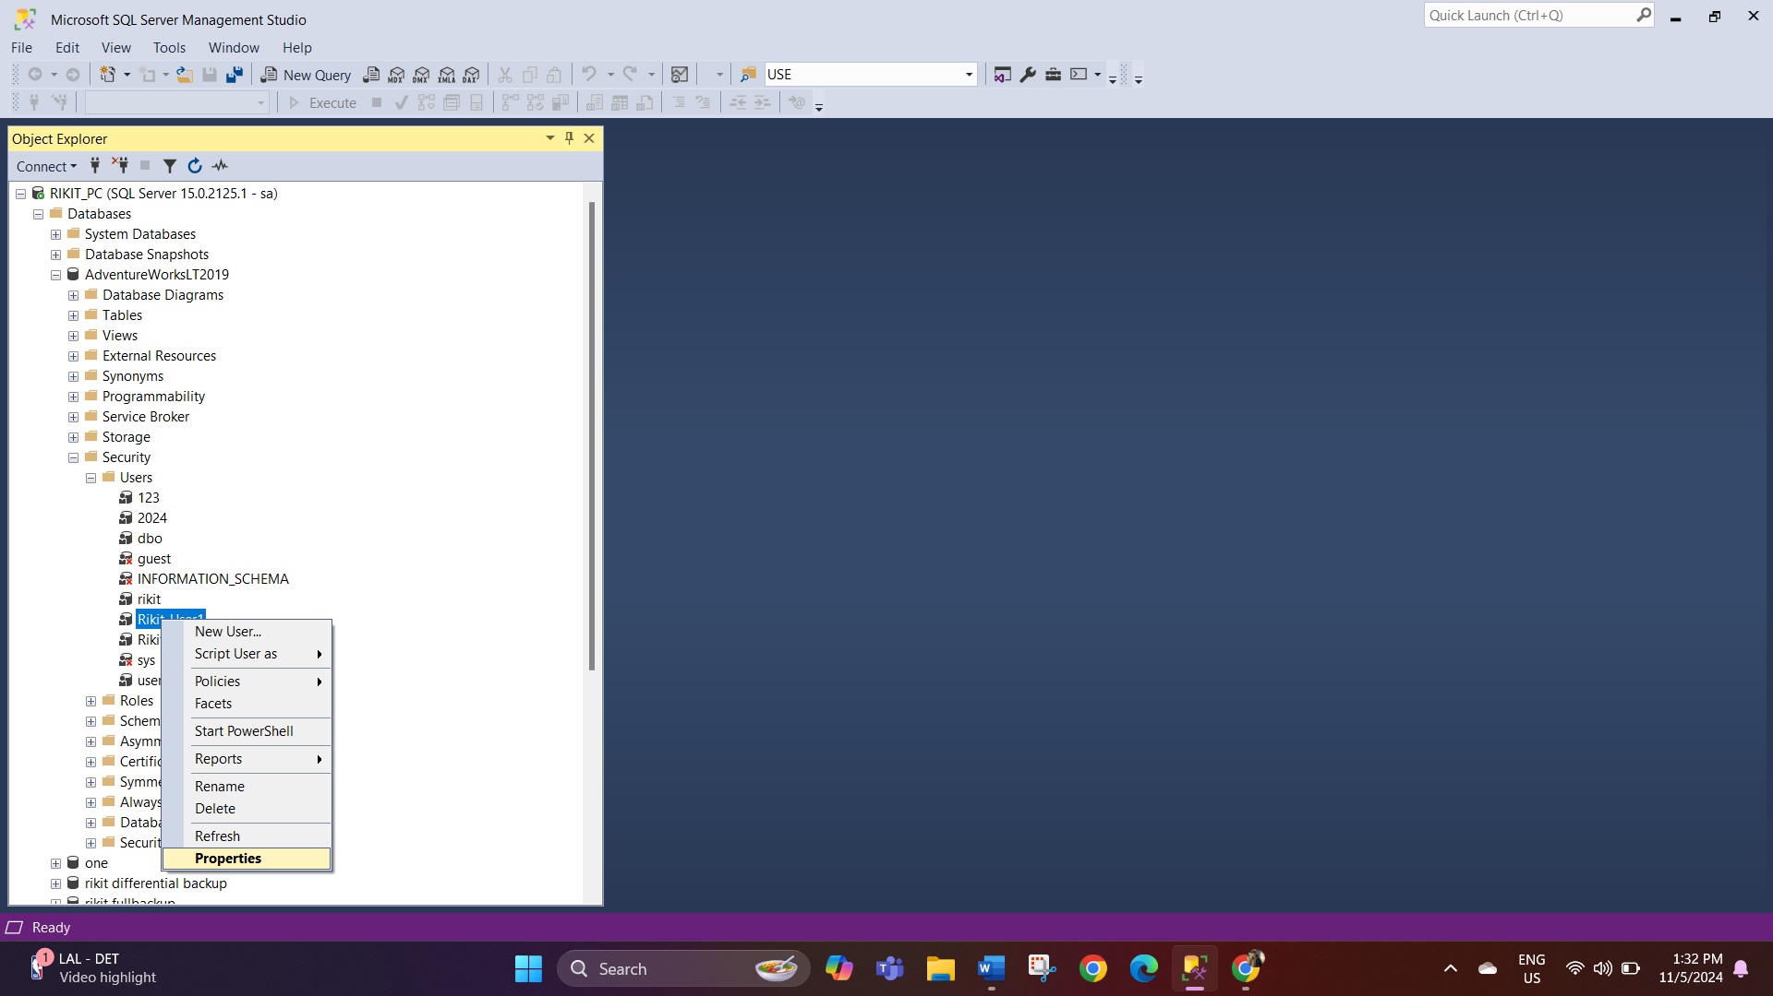

- As to the database User – Rikit_user1- leave the general page as a default. In the Owned schemas page, you must tick the schemas which that has to be owned by this user.
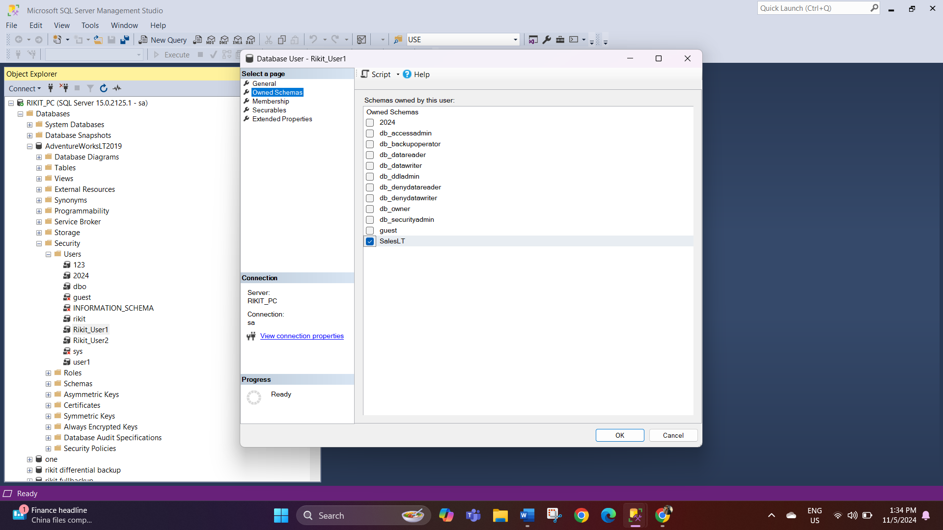

- On the membership page select the database role membership for this user and click ok button.
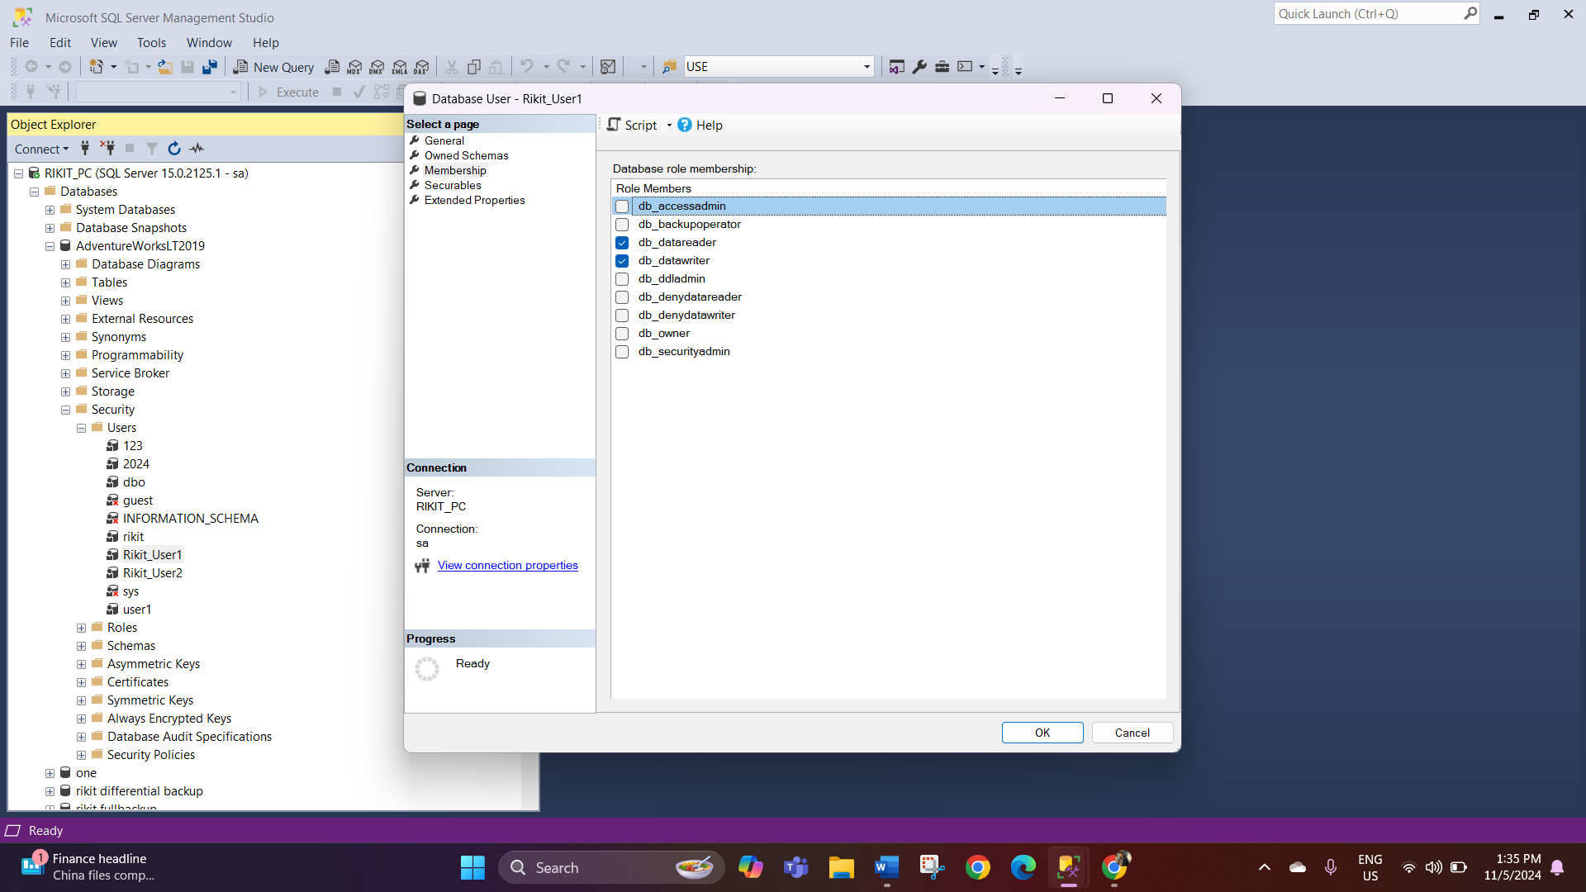

- On the securable page click on search and then the program will ask you what objects you want to add. Select all, then go to select specific objects and click ok.
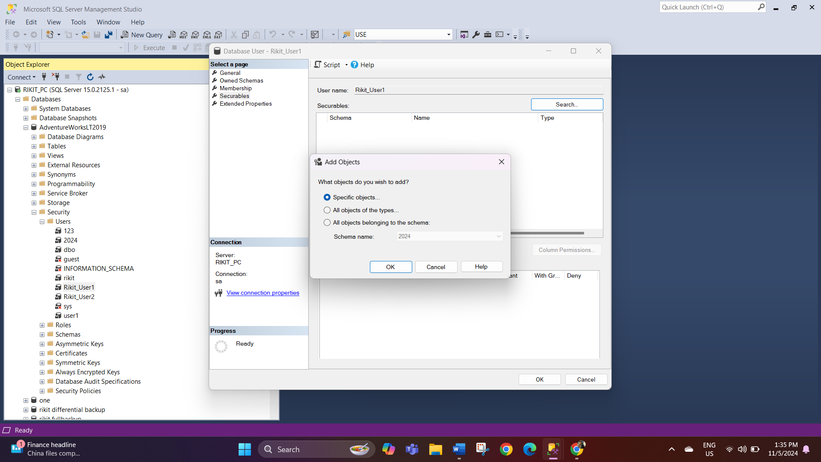
- Now, click on the object types and select the types of objects you want to look for. Here I again am choosing the Tables. After you have made the selection regarding the object type click ok.
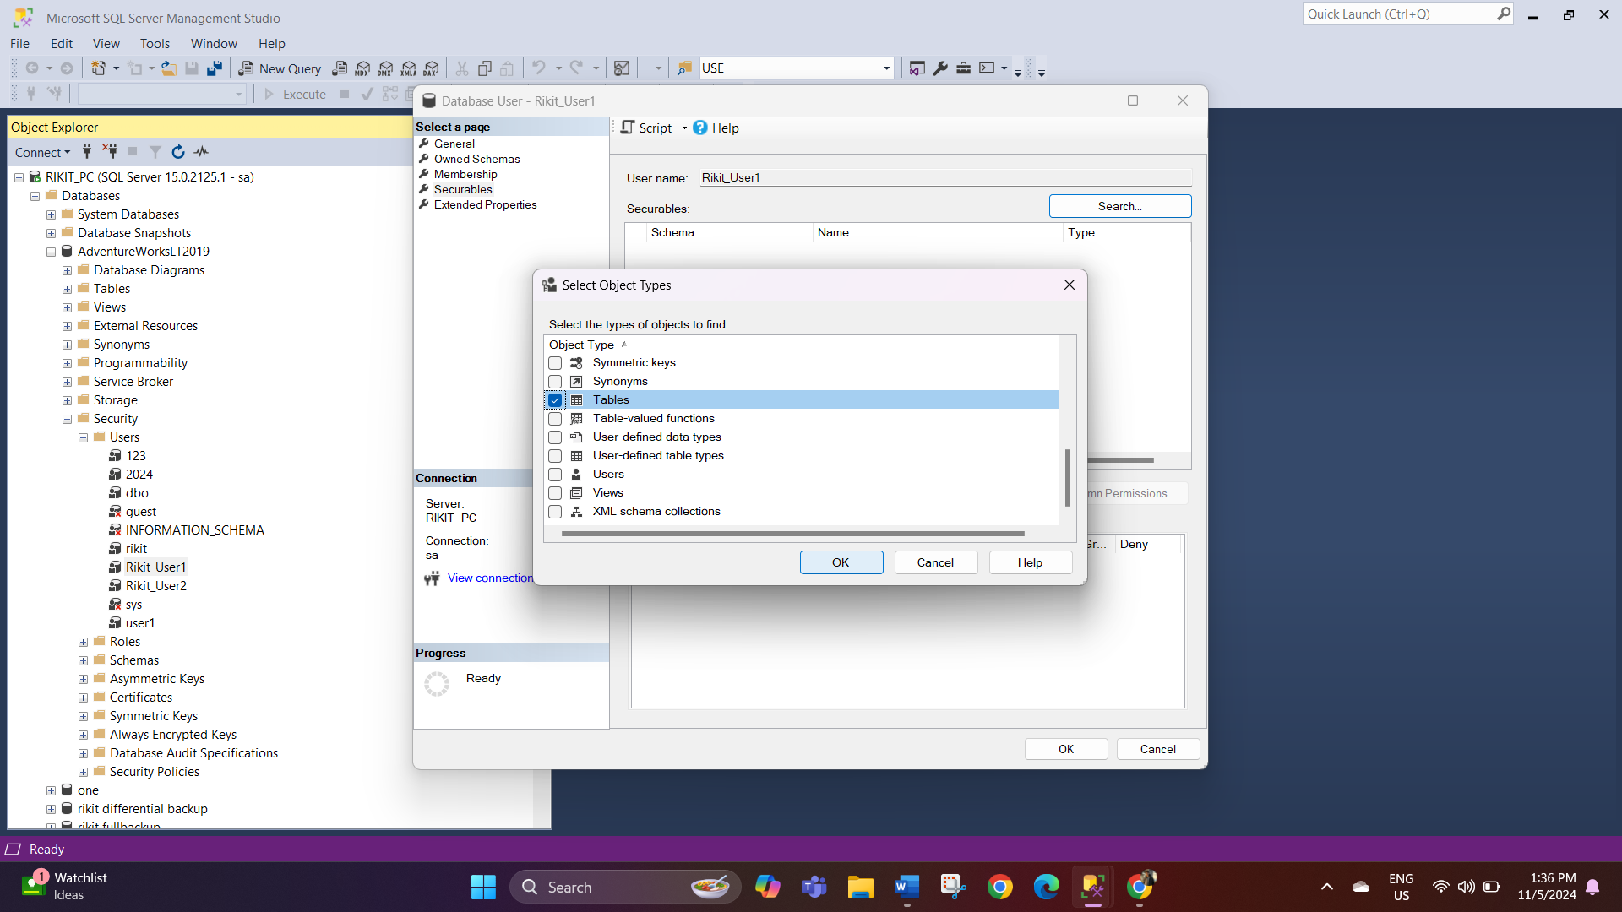
- Go to the table by clicking browse option and click ok on the table also.
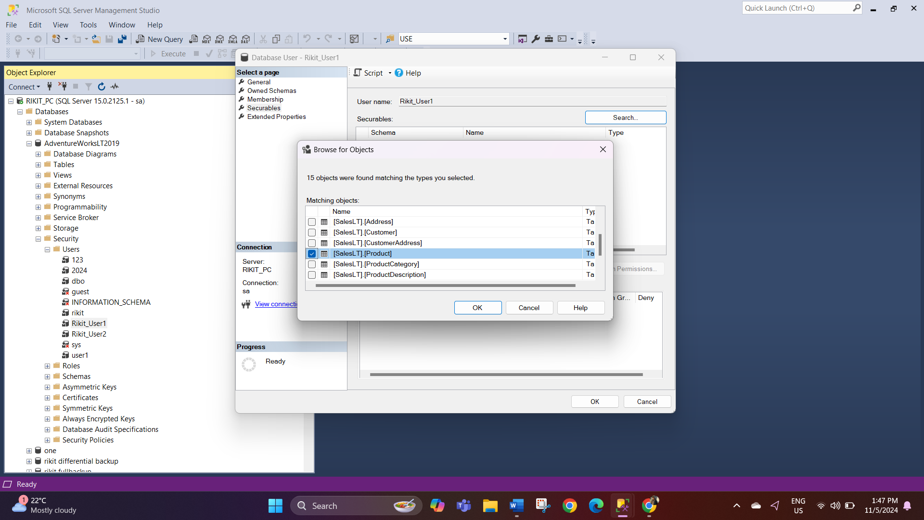
- On the next one you will see the table which you have chosen, and you can change the permissions as you wish It. Once you have selected your permission click on OK. For the user one we will give permission to select and update this table SalesLT. [Product].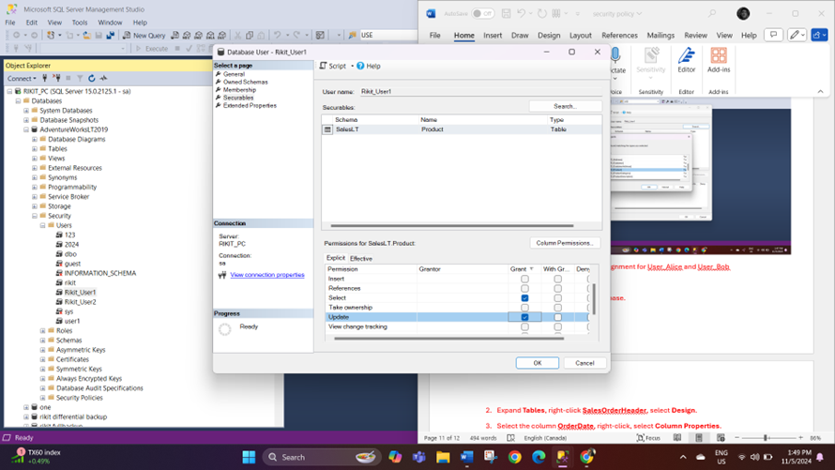

Denying permission for user 2

Repeat the same process for user 2 but this time deny the permission.
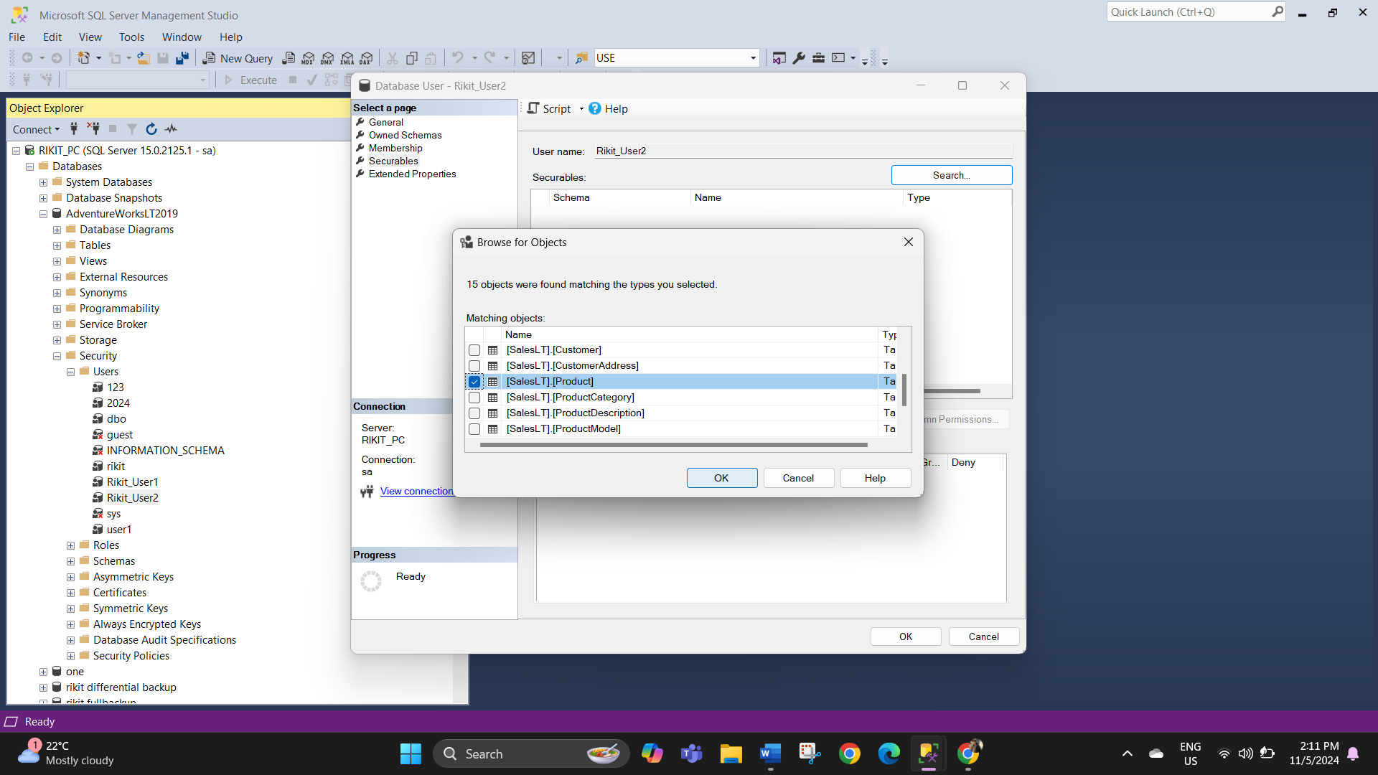

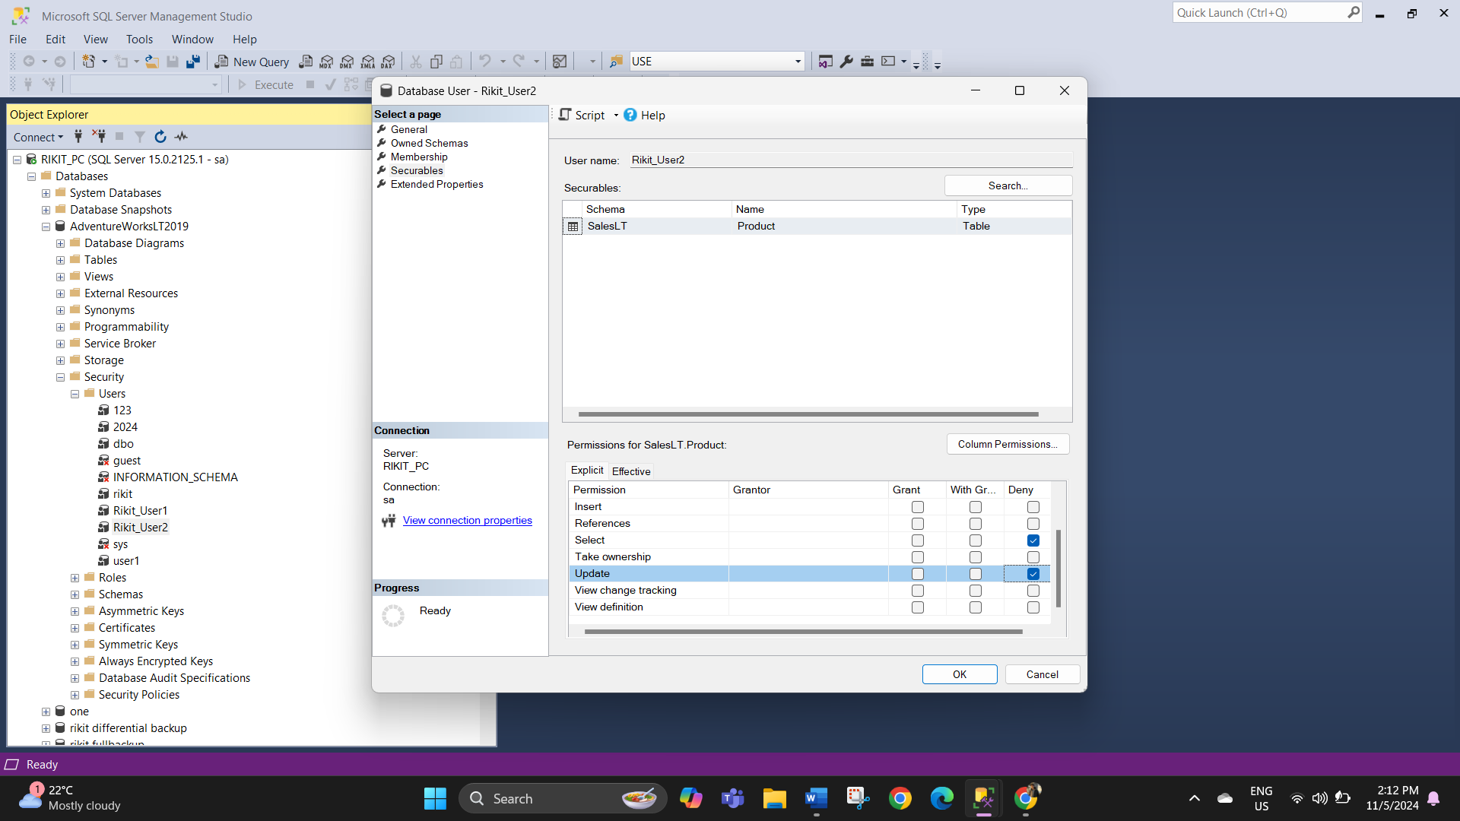

Test the Security Policies:
Test for User 1
- Login as as the first user to whom you have granted the permissions.
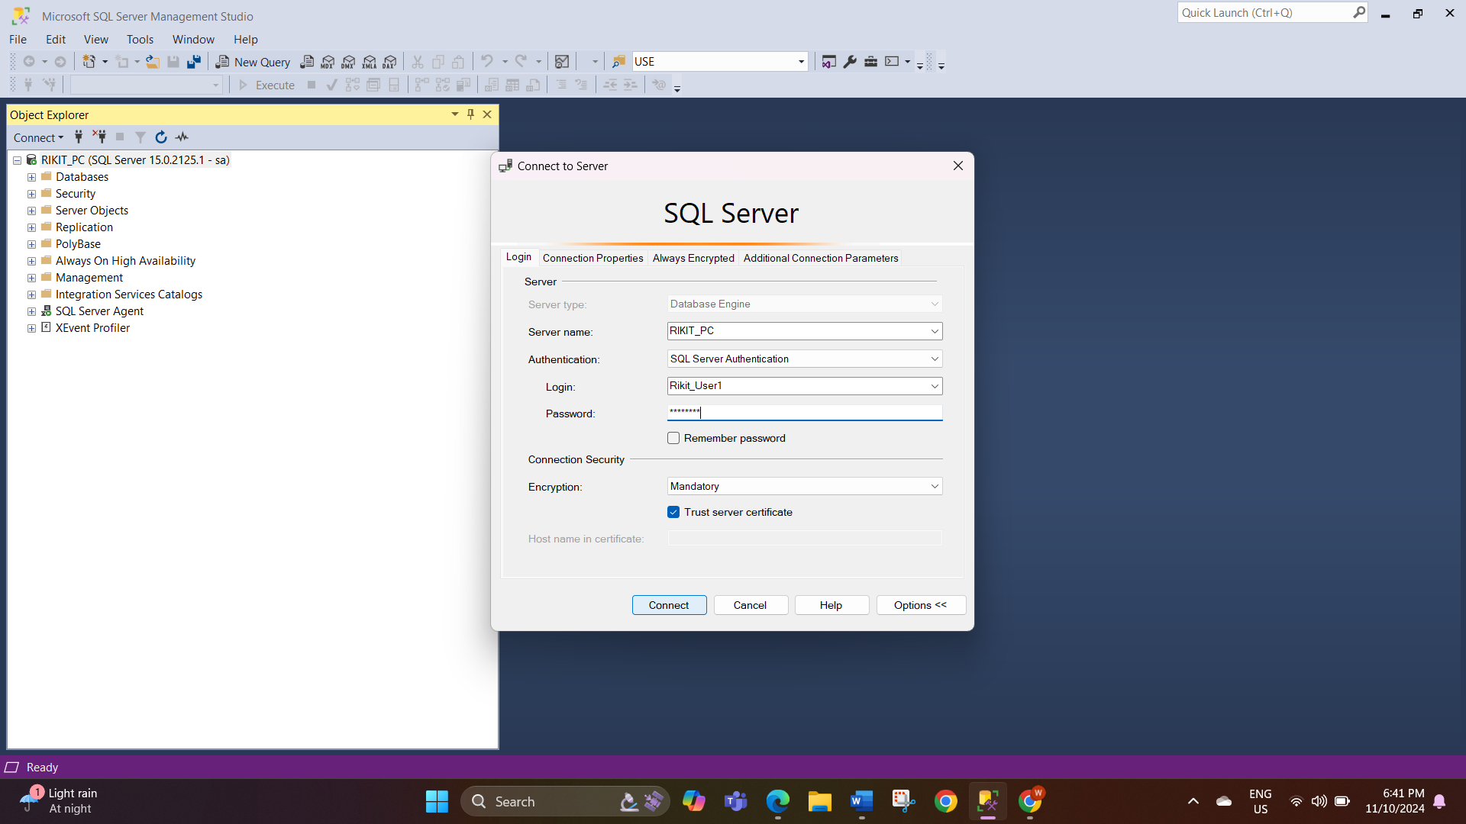
- Click on databases and select AdventureWorksLT2019 and Locate to the table and run the query. you must be able to run the select and update query without any problems.
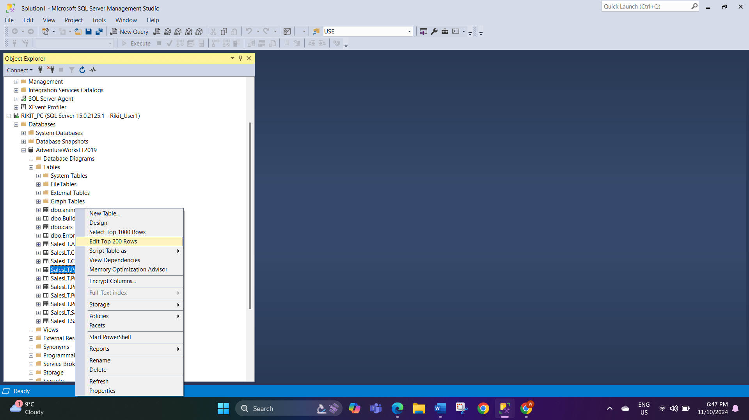
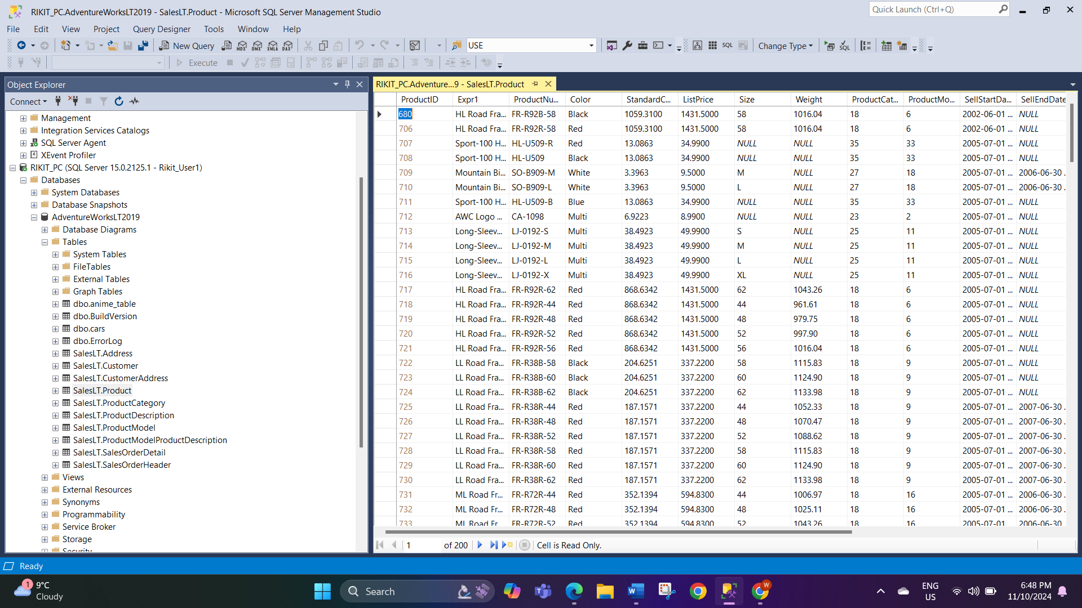

Test for User2.
- Login as the second user to whom we have denied permission.
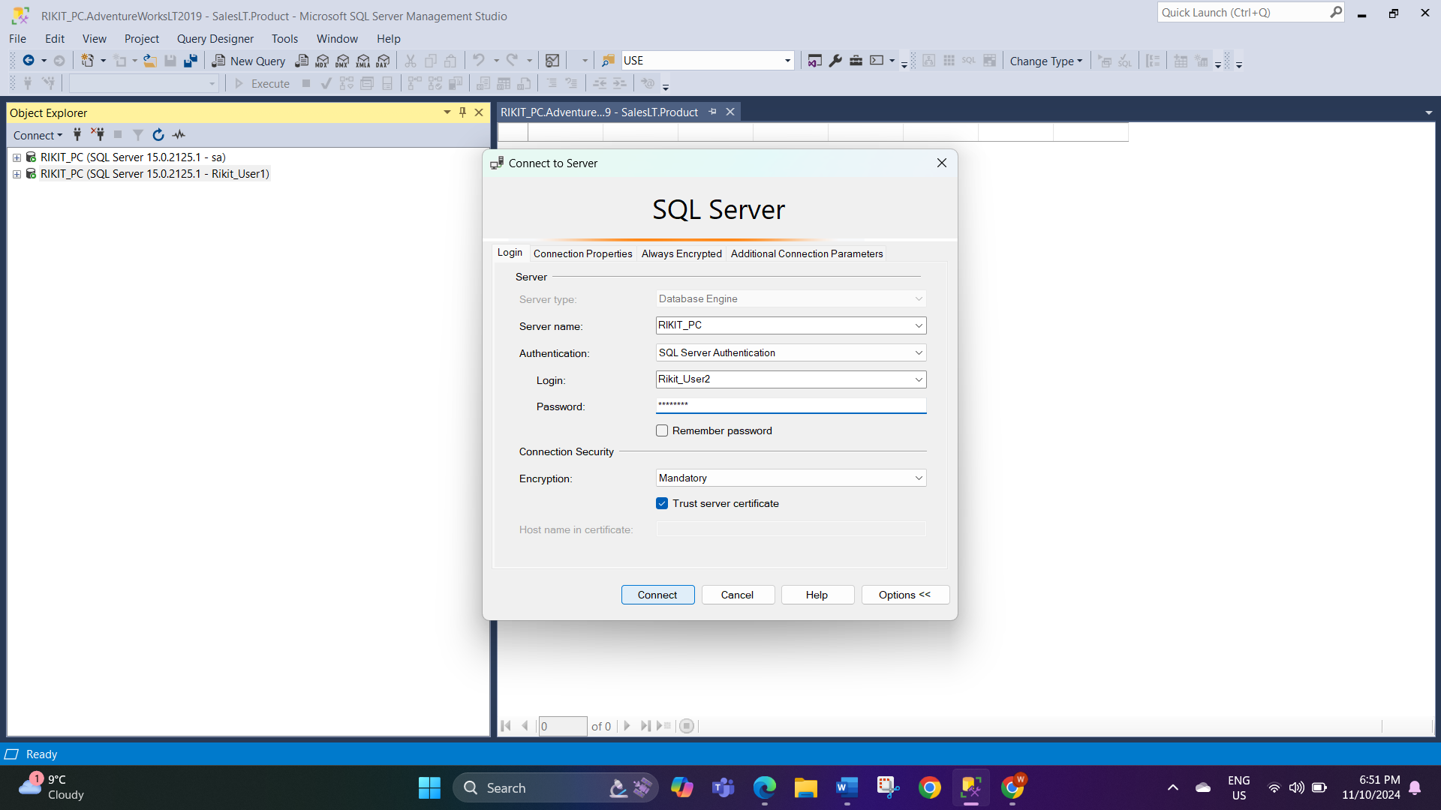

- Locate the table and try to run the query. This time you will get the SQL execution error as this user does not have the permission to do so.
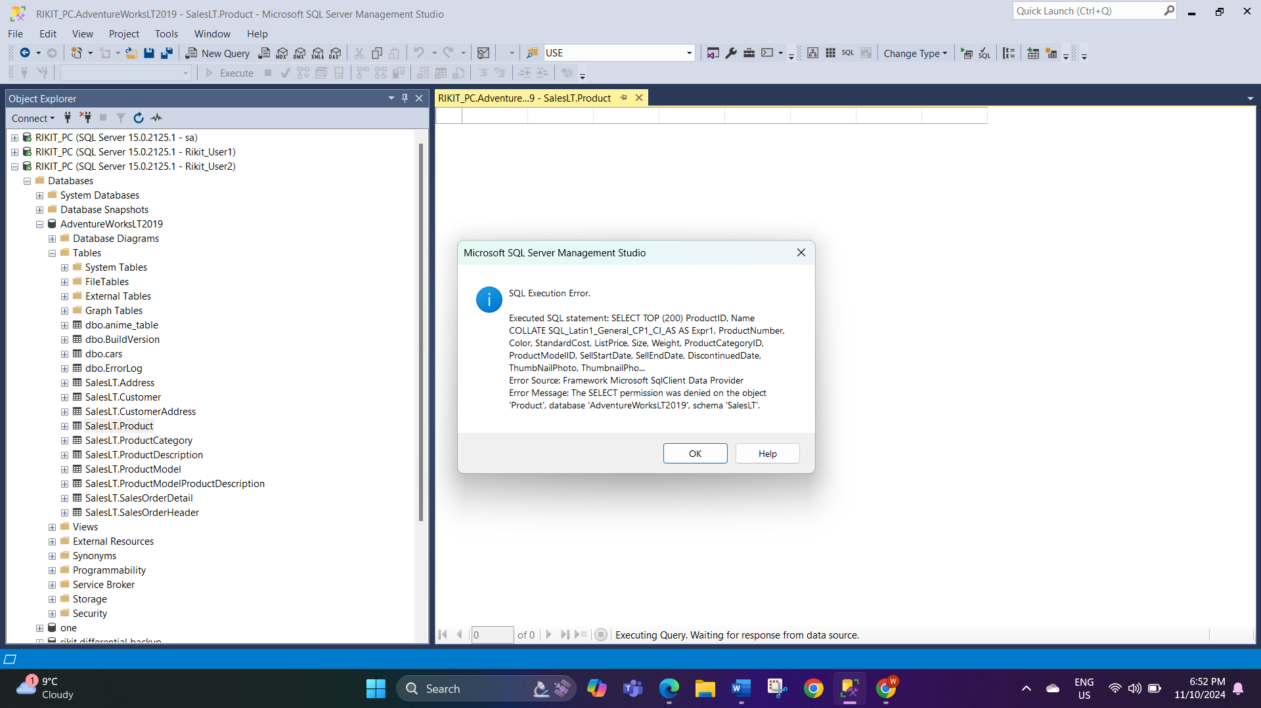

- DELIVERABLES
The final artefacts are a document that is titled ‘SQL Security Policy followed by checkpoints, guidelines on how to implement the policy measures, and actual screenshots of permitted user permissions as well as the implementation of access control measures; there is testing of the SQL Security Policy.

- AFFECTED PARTIES
This policy mainly implicates the IT Department, Database Administrators, accounting managers, purchasing managers, sales managers, and inventory managers as they shall be using the secure SQL resources.

- AFFECTED BUSINESS SYSTEMS OR PROCESSES
The policy is focused on SQL Server databases used by Accounting, Purchasing, Sales, and Inventory departments that is critical for core functions of the organizations to enhance data security and efficiency of data access.

- SPECIFIC EXCLUSIONS FROM SCOPE
Any data that is not stored or processed in an SQL based database or any data source external to Adventure Works is excluded from the policy’s purview so that it is easy to specifically concentrate only on the SQL Server database security of Adventure Works.

- IMPLEMENTATION PLAN
The policy implementation will follow a step-by-step approach: before fine-tuning the document, performing a pilot in a restricted development environment, and releasing it for production during the new facility launch.

- HIGH-LEVEL TIMELINE/SCHEDULE
We have clearly defined the following sequence of actions: first, the policy should be drafted not later than Nov 10th , and its testing and production no later than November 11. We will check the readiness and close the online course by November 13th though it will be fully secured and running by November 15th.

APPOROVAL AND AUTHORITY TO PROCEED
We approve the project as described above, and authorize the team to proceed.
Name | Title | Date
Rikit Thapa | Senior database Administrator | 13th November,2024

